Manual

LochMaster 3.0

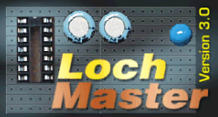

© ABACOM 2002

Contents

What´s new...?

1. Overview

2. Step by step...

Step 1 – A new board
Step 2 – Different views
Step 3 – How to add wires
Step 4 – How to change wires
Step 5 – Components from the library
Step 6 – Edit functions
Step 7 – File operations
Step 8 – Draw operations
Step 9 – Arrange functions

Step 10 – Adjust functions

Step 11 – Test function

Step 12 – Print

Step 13 – Component lists and annotations

Step 14 – Library operations

3. User-defined components

4. The board layout editor

5. Examples

What´s new...

A quick overview for all users that have already been working with an previous LochMaster version...

... compared with version 1.0?

- Comfortable 32-bit version with long filenames
- Several boards combined to one project stored in a single file
- „X-ray“ view makes components shine through from the opposite board side
- Undo function
- Unused areas of the board can be displayed
- Several types of strip boards are predefined
- Dockable tools offer customised toolbars
- Exact board dimensions and borders adjustable
- AutoSave option saves your work regularly

... compared with version 2.0?

- Bitmaps allow a simple and realistic component design
- File export for bitmaps or metafiles
- A new view option allows to look right through the board
- True colour resolution for pens and brushes
- Integrated text editor for comments, components list, instructions
- Editable board layout makes LochMaster usable with all types of strips boards
- Lots of predefined board types
- Improved test function also available for user-defined boards
- Contour function for automatic bending, rounding and chamfers
- Component assistant creates standard components with adjustable dimensions
- Drillings and millings available for cut-outs
- New, extended library revision with realistic looking components
- Board dimensions up to 300x300 mm.
- Improved printout of a whole project in one go
- Extensive bitmap collection for component design
- and other trifles...

1. Overview

LochMaster 3.0 is a developers tools for strip board solutions and can be helpful when...

- optimising the circuit outlines
- fitting the board to the cases
- optimising the components positions
- connecting and wiring the board and its components
- creating components lists
- determination of component types an values
- documentation and archiving

Lochmaster 3.0 supports strip boards with hole distances of 1/10“ and 1/5“. The maximum board size is 300 x 300 mm. The software provides all typical functions and operations you need, when working with strip boards.

- Selecting parts and components from the predefined, editable library and placing them on the board. All parts are movable in all three dimensions (x-,y-,z-axis)
- Creating components groups
- Rotation and duplication of components and groups
- Using blank or isolated wires, which can be bent and soldered ‚as in real life‘
- Splitting tracks
- Editable component values and components list
- Scalable printout of both board sides
- Test function for checking wiring of the board and following the signals flow.

This instruction is divided into five Chapters...

Chapter 2 leads you through the functions of the new software.

Chapter 3 teaches you, how to create your own parts and components. It is important to learn all about the basic functions from Chapter 2 before.

Chapter 4 introduces the board layout editor

Chapter 5 describes the examples, which have been delivered with the installation.

We are hopeful, that Lochmaster 3.0 is a useful tool for your strip board projects. Please feel free to send any comments to ABACOM.DEL@T-ONLINE.DE
Chapter 2 - Step by step

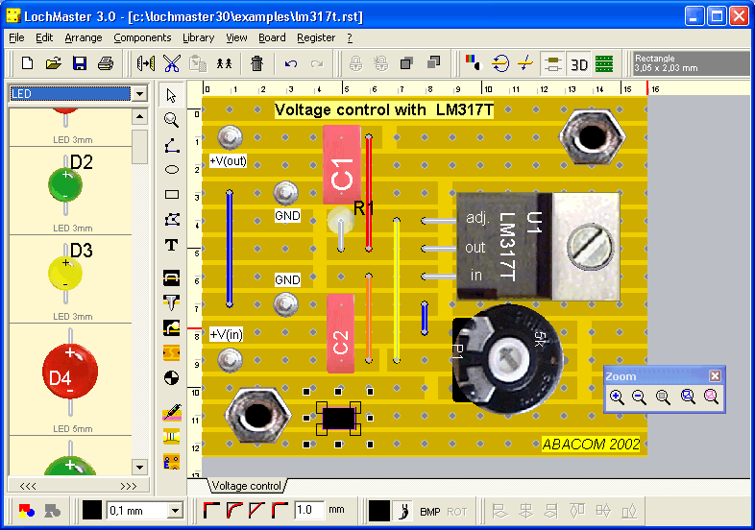

Fig. 1 - LochMaster 3.0 – the strip board editor

Fig. 1 shows the software and its components, started the first time.

- Menu
- Upper toolbar with tools
- Mode selector for the basic editing and drawing modes
- Components library containing parts and symbols
- Strip board with rulers and parts
- Moveable tools in the editor
- Board selector
- Lower toolbar with tools

LochMaster 3.0 displays helpful hints to all switches and tools, when the mouse is moved to one of these elements.

LochMaster 3.0 allows individual changes to toolbars (docking). Changes are saved automatically, when the software is terminated. So the software may look different from Fig.1, when it is restarted, and changes were made to the toolbars.

There are two toolbars above and beyond the strip board editor, containing several tools for changing colours, adjusting elements etc. The position of the tools within its toolbar is changeable and tools can be moved from one toolbar to the other. To do this, you find a small handle on the left of each group of tools. Click on the handle and move the tool to the preferred position, while holding the left mouse button down (drag). Drop the tool at the new position, by releasing the mouse button.

Tools can also be moved to the editor, where they are displayed in a small tool window. You may then close this tool window to hide the tool completely. Hidden tools can found in the main menu. Select VIEW->SHOW TOOLS to restore hidden tools.

The width of the component library is adjustable. You can decide yourself how much spaced is used for the library. Move the mouse to the right border of the library and drag the border line (between library and vertical toolbar) to a new position. The cursor appears as a double arrow to indicate this function. Hold down the mouse button and release the border line at its new position.

Step 1 – A new board

When starting the software, the last edited project is being loaded to the editor. A new empty board is being created automatically, if no existing project can be found

You can start a new project at any time with the NEW item of the FILE menu. You may be asked to save your first. After that a file dialogue will offer several board types (*.LMB) that can be opened. An empty board without copper and drillings will be created, if no board type is selected.

You can change the properties of the board, if necessary:

- Select BOARD->PROPERTIES from the main menu.
- Enter a short description to the field NAME, like ‚power supply‘
- Use the TYPE selector, to select a given board type

HEIGHT and WIDTH are filled with default values, when selecting a board type. Enter different width and height, if necessary. You may change the board OFFSET to move the copper layout lightly on the basic material (carrier). This is because the material sometimes is cut straight through the holes, or sometimes the cut runs between two holes. The offset is set to a default value, when you select a new board type. Change the values if necessary.
You may add additional boards to your project, by selecting BOARD->ADD BOARD from the main menu. You find an entry to each board in the board selector section. (Fig. 2)

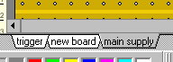
Fig. 2 Board selector

Click on one of these entries to show the board in the editor. You find some more operations on BOARDs in the main menu. Use them to DELETE or DUBLICATE boards. Use IMPORT to add all boards from an existing LochMaster project file (*.rst) to the current project. Select BOARD->TO LEFT/RIGHT or BOARD->MOVE LEFT/RIGHT from the main menu to sort the entries of the board selector. You can also reach the board operations from a local context menu. Click with the RIGHT mouse button on the board selector, to open the local menu.

Step 2 – Different views

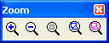

You can change the view of the board, using the tool ZOOM. Use the buttons (+) and (-) to adjust the magnification. The button BOARD adjusts the zoom so that the whole board is visible in the editor. The button COMPONENTS makes all components fit the screen. The button SELECTION displays all selected parts on the screen.

Another way to adjust the zoom is to switch the mode selector to ZOOM-mode and then move the mouse cursor (magnification glass) to the editor. In zoom mode the left mouse button increases the magnification, the right mouse button decreases it. You can also draw a rectangle that includes the area to be zoomed. After you finished zoom adjustment set the mode selector to DEFAULT mode (arrow).
If the board does not fit the editor screen, because of its magnification, you get scrollbars on the left and lower edges of the editor. The rulers on the left and upper edges of the editor help you, to count the row and column you are working at.

The board can be displayed in different views on the screen or printed. The tool VIEW offers the following functions.

- Colour mode and black and white (outline) mode
- Solder and component side of the board (turn over)
- Solder and component side of the board (right trough)
- ‚X-ray‘ makes components on the opposite side shine through
- Bitmap fillings on/off
- Show unused board areas

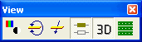

The black and white (outline) mode may be useful, to work on parts that are overlapped by other components. This display mode may also be used with b/w-printers to improve the readability of the printout.

Bitmap fillings should usually be turned on. You can turn them off on older computers that are to slow to process bitmaps without acceptable delay.

You can combine any of these display options freely. They do not affect your project in any way, but simply display your board differently.

Step 3 – How to add wires

To realise a wired connection on the board, do the following:

Switch the mode selector to the mode WIRE.

Move the mouse cursor to the board, and click on the wanted start position of the wire. The wire has now been created and you can solder the other end of the wire with another mouse click. You can also use the right mouse button to cancel the wire and restart from another position.

If you wish to bend a wire hold the CTRL-Key on your keyboard down. In that case the end of the wire is not being soldered to the board, but you get a bend point from which you can go on to another position, until you release the CTRL-key to finish the wire. If you have to reach a position between the holes, hold the SHIFT key down. As long as the wire is not finished, you can use the right mouse button, to undo the last wire operation.

Step 4 – How to change wires

Switch the mode selector to default mode.

In this mode the mouse cursor may change to inform you about possible operations.

Cursor: Arrow....
Your are pointing to an area, where nothing is placed at. A click to this position unselects all components.

Cursor: Pointing hand...
You are pointing to an unselected component. You may click here, to select the component.

Cursor: Arrow...
You are moving on a selected component. You may click and hold the left mouse button down, to move the selected component(s) to another position.

Cursor: Cross + modify
You are pointing to a changeable point of a wire or a line.

Do the following to change a wire:

Click on the wire you want to change. The wire changes its colour to magenta, to show that you have selected it.

If you have selected a wire you can...

...change the start or end point of the wire
Click on one of the extreme points of the wire. The wire is now unsoldered from the board, so you can solder it at another position. See also Step 3 - Wiring

...move the bend point of a wire
Click to a bend point and move it to another position, while you hold the left mouse button down.

...move the wire
Move the mouse on the wire, until the cursor changes to flat hand. Then hold the left mouse button down and drag and drop the wire to its new position.

... change the diameter or the colour of a wire (isolation)
Click on one of the colours from the colour palette tool. The wire will change its colour. Avoid magenta to make sure, that you can see the difference between selected and unselected wires. Select a diameter from the WIDTH tool.

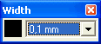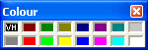

...change the contour

Select the corresponding function to assign bending, rounding or chamfers to a wire or other object. Enter a value for radius/length of the rounding/chamfer to the edit field before.

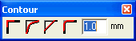

Remember that you have to select an object, before you can assign new values using these functions!

Step 5 – Adding components to the board

Components can be selected from the library and can be placed anywhere on the board.
You can also use the component assistant to create often needed components with various dimensions.

The library consists of several pages, which contain the predefined components. You will find resistors, capacitors etc. in it. To select a page, use the listbox on top of the library. You can find a page very easily, pressing the first letter of the page name on the keyboard.

If you click on a multipin component in the library, the mouse cursor is moved to the editor and the selected component sticks to the mouse cursor. With a click you can solder it at the wanted position. You may cancel the operation using the right mouse button. As long as the component is not soldered to the board, you can use the SPACE-key on the keyboard to rotate the component. Some components request the entry of some component data (type, value etc.) – Fig. 3

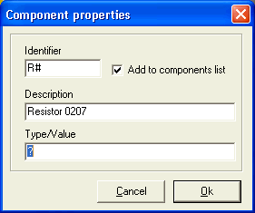
Fig. 3 - Component properties

The ‚#‘ character in the field IDENTIFIER represents the component number, when using the automatic component numbering option. When you add the component to the board, the software determines the component number for this specific component.

Example: Resistor R1 and R2 already exist on the board. If you add another resistor, its short name is set to R3 automatically. You may override the identifier with an absolute name ‚R123‘ (without ‚#‘ character). In that case renumber operations to this component will NOT be performed.

The field DESCRIPTION is used to display the component in the library and the description appears in the components list. The field TYPE/VALUE can be used for additional information to the component. For components like symbols, you may deactivate the option ADD TO COMPONENTS LIST, so that they do not appear in the components list.

Coaxial components:
Adding coaxial components like resistors to the board works exactly like adding wires (see step 3).

The component assistant

You can use the component assistant to create often needed components with various dimensions. Simply select an object from the object list and enter the properties to the parameter list.

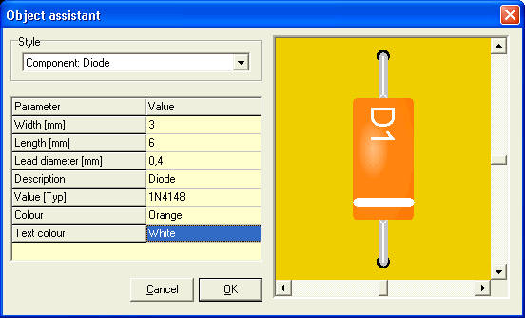

The available parameters depend on the object type you have selected. Numeric values can be entered directly from the keyboard. YES/NO selections can be change using the Y and N key of the keybord, as well as the SPACE bar, or with a double click. The result can be preview directly. Select OK to create and add the component to board.
Step 6 – Edit functions

witch the mode selector to default edit mode. The editing-functions COPY, CUT, DELETE, etc. work, as they do in Windows: First select the object to perform an operation on, and then call the edit function.

Selected objects appear magenta coloured. Select an object with a click. If more than one object has to be selected, hold the SHIFT key down on your keyboard. To deselect an object, click it again, while holding the SHIFT key down. Other object will remain selected. Instead of clicking each individual object to select it, you can also draw a frame to select all object that cross the frame. To deselect all selected objects, click to an area, where NO object is located. Use the main menu entry to SELECT ALL objects on the board. Additional information about selected objects is displayed on the INFO-display tool. After selecting some components of the board, you can perform an operation from the EDIT menu:

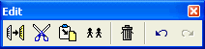

DELETE: deletes all selected objects. You can also reach this operation, by pressing the DEL-key on your keyboard. COPY copies the selected objects to the clipboard. As the objects are special components of a strip board (including component data etc.) you can NOT paste these object to other applications. CUT first copies the selected objects to the clipboard and deletes them from the board. PASTE adds components from the clipboard to the strip board. This works similar to adding components from the library, but no component data is requested. DUBLICATE performs COPY and PASTE with a single step. ROTATE: Objects are cut from the board, copied to the clipboard and rotated with an angle of 90 degrees. After that you have to reposition it on the board. While doing this, you can rotate the component again, using the SPACE-key of the keyboard.

Edit functions may be disabled, depending on your selection. For operations like COPY and CUT at least one object has to be selected. ROTATE is only available with a single component or group selected. Edit functions can also be called using the toolbar buttons. If default edit mode is set, you can also reach these functions by pressing the right mouse button, to get a local context menu.

To MOVE components, select them and drag & drop them to the wanted position.
While moving objects, objects are captured to fit the grid. You can enable a finer grid capture using the SHIFT key of your keyboard. This fine grid can be adjusted from 0...2,54 mm. Therefore select VIEW->FINE GRID from the main menu.

When cutting or deleting components, the remaining components will NOT be renumbered. Select COMPONENTS->RENUMBER from the main menu, to renumber components. You may undo your last performed operation by selecting UNDO from the main menu or pressing <alt><backspace> on the keyboard.

Step 7 – File functions

The FILE menu contains the well known operations SAVE, SAVE AS, OPEN and NEW, as well as PRINT and QUIT. LochMaster saves your projects to a files with the extension *.rst. The file includes all boards with their components, including the component data as well as annotations, etc.. Because of the specific file format these files can not be imported to other applications. The current filename is displayed in the programs headline. The file extension *.rst is linked with LochMaster 3.0 automatically when, the software is installed. You can simply click to a project file (*.rst) in the Windows Explorer to start the program and load a project.

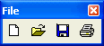

Use SAVE to write changes to the file displayed in the programs headline. If you created a new project the filename is set to NONAME.RST. In that case SAVE AS is called, so you can give a name to your project. Use SAVE AS to rename your project, or save it to another position. If you do not type the extension, the extension *.rst will be added to the filename. You better don’t use other extensions. If a project file was created by an older version of LochMaster, it will be converted to the new file format. After saving such a file, you can no longer use it with the older version! Always use the latest program version! Use OPEN to read a project from file. The last edited file is loaded automatically, when LochMaster is being started. If you select NEW from the file menu, all boards of your project will be deleted. Before that you will be asked to save your project. To start a new project, you will be asked to enter the properties for the first board.

AutoSave
Select FILE->AUTOSAVE from the main menu. If the option is activated, your project will be saved in the given interval, using the extension *.BAK. If you have to use the BAK-file for some reasons, you can simply open it. File extension will then be changed from *.bak to *.rst, so you can continue your work immediately.

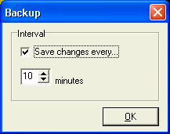
Step 8 – Draw functions

There are basic drawing functions to draw lines, rectangles, circles, polygons and text. Extended drawing functions are PIN, CONNECTION, DRILLING and SPLIT.

Basic drawing modes:

Set the mode selector to LINE, to draw a line. Click to the starting point of the line, then click again to determine the next point of the line, and so on. Use the right mouse button, if you finished the line. As long as line mode is selected, you can continue with more lines, until you select another edit mode. You can easily reach the default edit mode from every other mode, by pressing the right mouse button.

All basic drawing modes use a black pen with a width of 0,1 mm. You can assign different colours or widths from the toolbar. To change colour or width later, select default edit mode, select the objects to change and then adjust colour and width.

Set the mode selector to RECT, to draw a rectangle. Click to the rectangles top left corner and click again to its bottom right corner. If you want the rectangle to be filled, select the option FILL from the toolbar. To select the fill colour click to the colour palette, using the right mouse button.

Set the mode selector to CIRCLE.First click to the circles centre. Move the mouse, to adjust the radius and click again. Adjust width and colours.

Set the mode selector to POLYGON. Polygons are draw in the same way as lines, but the figure is closed automatically when finished.

Filled object
Closed figures (i.e. circles, rectangles and polygons) can be filled with a simple colour or with a bitmap picture and the filling can be turned on and off.

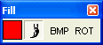

Select some objects that can be filled first. Turn on the fill option for these elements. A simple colour can now be assigned with a click with the right mouse button on the colour palette. A user defined colour can be assigned with a click on colour field of the FILL tool.
The BMP button loads a bitmap from a bitmap file (*.bmp). Lots of useful bitmaps have been installed with the software to the BITMAPS directory. A bitmap is unloaded again when a simple colour fill is assigned to an object. Bitmaps are automatically stretched to a size that fills out the assigned object completely. In case the loaded bitmap has a bad orientation, use the ROT button to rotate the bitmap in steps of 90°.

Important notes for use of bitmaps!

- Minimise the size of bitmap files (resolution, file size) whenever possible. Mostly bitmaps with a size of 100x100 pixels maximum are sufficient for a satisfying result. Especially bitmaps for user defined components should not be greater than a few kByte. Also refer to the examples in the BITMAPS directory!
- Avoid true-colour-resolution of bitmaps and convert them to bitmaps with 256 colours (8 bit palette) with a graphic softcware, before you use them with LochMaster.

Large bitmaps may otherwise reduce performance speed, especially when running LochMaster 3.0 on older computer systems.

Set the mode selector to TEXT, to add a text to the board. Click to the text position and then enter the text to the dialog.

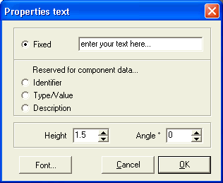

The option FIXED must be selected. You may adjust the height and angle if necessary.
The VARIABLE options are provided for use with creation of your own components. Press the button FONT to change the font for the text label. Click OK to add the text to the board. You may change the text later, if you return to default edit mode and click the text with the right mouse button. Select PROPERTIES to change the text. You can also adjust colour using the palette.

Extended drawing modes:
These modes were designed for use with creation of your own library components.

Wires are soldered with both endings to the board. To create your own components you need two more objects, which indicate the kind of connection that is used to contact the component to the board.

CONNECTIONS consist of a piece of wire, where one end is soldered to the board and the other end is fixed to the component. You find that kind of connections with resistors, capacitors, diodes etc. Drawing connections is like drawing wires. Set the mode selector to CON. The first click marks the soldered end of the connection. Drawing direction always is from the board to the component.

PINS that are soldered orthogonal to the board and run straight from the board to the component, such as IC-pins To draw a pin, set the mode selector to PIN, and click to the position, where you want a pin to be soldered.

If you are drawing your circuit or component, always make sure, what kind of object you use. WIRE, PIN or CONNECTION. This is very important, to take advantage of the test function and to make your own components work in the way you want it to.

To set a SPLIT to the copper layout, set the mode selector to SPLIT.
A split is set with a single click. To adjust the size of the split, click the left or right half of the split and hold the mouse button down, while moving the mouse.

Set the mode selector to drill mode.

A dialogue requests the drill diameter. You set a drilling with a single click anywhere on the board. This mode is terminated with the right mouse button. Drillings are visible from both sides of a board.

Millings appear as well on both sides of a board. Millings are drawn with the basic drawing function LINE, RECTANGLE, CIRCLE and POLYGON. If you hve selected some of these elements, you can convert them to millings, using the MILL tool. Use this tool also to convert millings back to their original contour.

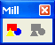

Step 9 – Arrange functions

You can arrange objects by setting their z-position and combining them to groups. The functions are settled in the main menu item ARRANGE and can also be called from the toolbar.

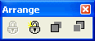

To front / To back
Select the objects that have to be arranged. Example: You have added a resistor to your board and then drawn a wire over it. Now you wish to put the wire under the resistor. Select the wire and call ARRANGE->TO BACK. You could also select the resistor and call TO FRONT, which would have the same effect. If you select more than one object to use with these functions, all selected objects will be set to front or to back, but the relation between the selected objects will stay untouched.

There are two exceptions where z-order of object can not be changed: Text objects will always stay in front, so that they are readable. Splitter will always stay in the back, because they are directly combined with the copper layout.

Building groups
Objects can be combined to groups, to make them selectable and editable with one single click. Groups also protect their elements against unwanted changes in colour etc. Members of a group can not be deleted separately, but the soldered ends of wires and connections are editable. You need at least two elements to build a group and a group can contain one or more sub-groups. To build a group, select the members and call ARRANGE-BUILD GROUP.

Splitting groups
If you wish to edit a group member separately you have to split the group. Select the group and then perform ARRANGE-SPLIT GROUP. If the group contains subgroups these will stay untouched. You may repeat this action with the subgroup.

Step 10 – Adjust functions

Use the tool ADJUST to adjust simple elements of your drawing like rectangles, circles, text etc. Select all objects that have to be adjusted. The last selected object is the reference object, which will stay at its position.Then click to the ADJUST tool to select the direction of adjustment. The reference object can be a complex element like a group or component.

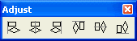

Step 11 – Test function

To test the board set the mode selector to TEST. This mode is helpful to follow the signals flow and find wanted or unwanted connections. Click to one point of the circuit, and the program will find all areas of the board that are connected directly to that point. Wires, connections, and pins will be considered, but the software can not find connection that are build with 0-Ohm-resistors. Connected areas are marked with the colour magenta until you click to another position, or select another edit mode.

Step 12 – Print

Select FILE->PRINT to get a preview of the printout. The preview is oriented to the paper format that you selected for your printer. The printout can be adjusted somewhere on the paper and several options can be selected. Simply drag and drop the printout to the desired position in the preview. The red border indicates the printable range of your printer. Magnification is adjustable between 100% and 500%.

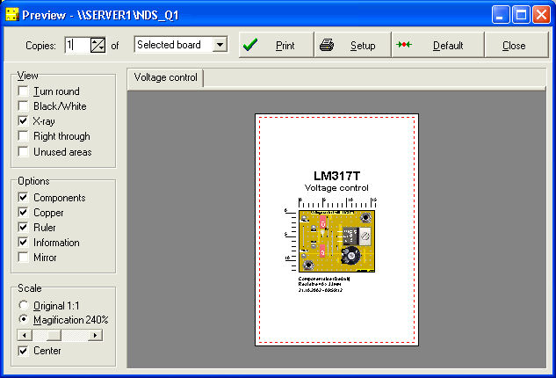

The options TURN ROUND, Black/White,X-RAY, RIGHT THROUGH and UNUSED AREAS are the same as in the editor. You can look at the preview to see what effect each option will take. Click the DEFAULT button to restore the default setting for the printout. Click the SETUP button to enter the printer setup options that depend on your printer. You can enter the number of COPIES printed, either of the selected board or of all boards of a project.

We suppose to save your work, before starting the printout by clicking the print button.
The printout should look like the preview, if not... well, try different printer drivers, even if printout with other applications seems to be correct!!!! Different drivers can be taken from the Windows-CD or the Internet.

Step 13 – Component lists and annotations

Component lists
The software creates a component list from the components data automatically. Select COMPONENTS LIST from the BOARD menu. There are two kinds of lists that can be created. The first one contains an entry for each component used with the board, the second is an ORDER LIST that collects components with the same data to one entry in the list. You can edit the components list and save as text file (*.txt or *.rtf) or print it. Use the toolbar in the list window. The list is only created temporary and changes are lost if the list is closed. It is recommended using the following ANNOTATIONS option, if you have to save to components list together with your project.

Annotations

The menu item ANNOTATIONS can also be found in the BOARD menu. A text editor opens and allows you to enter comments, construction hints, components lists or anything else to each board of your project. The annotations are saved together with your project file automatically. Again you find buttons for creation of component lists and order lists in the toolbar. Annotations are part of your project, which means that they are save when the text editor is closed. You can open and close the annotations whenever you like. Annotations refer to the board that is activated with the board selector. Each board has its own annotations.

Step 14 – Library operations

The library consists of several pages with components on it. You can adapt the library by creating new pages, adding components, renaming, deleting or sorting them. The library is stored in the directory LIB of the installation. Library file are saved automatically, when...

- using file functions
- changing the library page
- terminating the software

To create a backup of the library files simply copy the lib directory to a save position.

Creating a new library page:
Select LIBRARY->NEW PAGE from the main menu. You are asked to enter a name for the new page. After confirmation the library will contain your new empty page.

Deleting a library page:
Select LIBRARY->DELETE PAGE from the main menu. After confirmation the page will be deleted and is then gone forever.

Renaming a library page:
Select LIBRARY->RENAME PAGE from the main menu and enter the new name.

These functions are also reachable by a local context menu, if you click with the right mouse button on a component that is still in the library. Here you will also find the functions TOP and BOTTOM to sort the library. The entry PROPERTIES allows you to modify the component data of a library component. Changes will not effect the components that have already been placed on the board.

3. User-defined components

A user-component consist of at least two elements like lines, rectangles, circles, polygons, text, as well as wires, connections, pins and groups of these elements. Basically a component is a group with additional information: The component data. (Identifier, description, type / value)

The first thing to consider is what elements a component consists of. A simple symbol like an arrow may consist of a polygon and a line. To build a component from these two elements you have to mark them and then select ADD TO LIBRARY from the LIBRARY menu.

You now have to enter the component data of your new component. For a simple symbol like an arrow only the field DESCRIPTION is necessary. You can enter a name like ‚My Arrow‘. The arrow will then appear on the current library page and will show its description ‚My arrow‘. It can now be used as any other component.

Now we can try to create a simple IC-component, like a timer NE555, which is delivered in a DIL8-case. The case can be draw as a rectangle, and 8 PINs are necessary for the connections. Additional two text elements are used to display the TYPE (‚NE555‘) and the IDENTIFIER (‚IC1‘). You already learned how to add a text object to the board. So far you always selected the option FIXED in the texts property dialog. Of course you can add a fixed text ‚NE555‘ to your component, but it is more effective to have the text object filled from the components data fields, so that text is editable when the component is added to the board.

So if you add the text object, to display the components type (NE555), select VARIABLE (TYPE/VALUE) in the property dialog. For the text, that will display the identifier later, select the text option VARIABLE (IDENTIFIER). Now add the text objects <<ID>> and <<TYPE>> to your component. The type and identifier will be replaced automatically later.

So far we have drawn a rectangle, 8 pins and 2 variable text objects. Now they have to be combined to one component. This is done by selecting the objects, the component consist of, and then calling COMPONENT->BUILD COMPONENT from the main menu. Now the component data for the component is being requested.
Enter ‚IC#‘ to the field IDENTIFIER. The #-character stands for the component number, and will be replaced automatically when the component is added to the board. Enter ‚timer‘ to the field DISPRIPTION. The field TYPE/VALUE of course you fill with ‚NE555‘. If you choose the option ADD TO COMPONENTS LIST the component will appear in the components list (default). Disable this option when your are building symbols (like arrows) that you do not wish to appear in the components list. If you close the component data dialog with OK, the component is being build from its elements and component data is filled to variable text objects. Instead of COMPONENT->BUILT COMPONENT you could have selected ADD TO LIBRARY as well.

Changing and editing of components:
Sometimes you may wish to modify a component. In that case place the component to an empty area of the board and the select COMPONENT->SPLIT COMPONENT. The component is then being split to its elements, so you can make your changes on it. When you finished your changes you have to build the component and enter its data again.

If you just want to make change to a component data, you click on it with the right mouse button and select PROPERTIES.

In some cases you will not know the components type or value in advance. In that case you enter a ‚?‘ to the data field. This indicates that data will be requested later, when the component is taken from the library.

Special components: Dipoles
Dipoles are defined as components, which have exactly two connection wires, fitting the same axis. (Like resistors, diodes, etc.). Dipoles are drawn and build as any other component, but you must not use pins, wires or splitter in the dipole. Ones again: Dipoles must have two connection wires on one axis.

If you use bitmap fillings as part of the dipole definition, please consider that bitmaps are NOT rotated with the dipole when the dipole is rotated to an other angle. It is recommended using only bitmaps with light colour effects, or even better not to use bitmaps with dipoles.

4. The board layout editor

While LochMaster 3.0 already offers several predefined board types, you can now even create your own boards. So you can use LochMaster 3.0 with any board type you can imagine.

The board layout editor is open with a click on the corresponding button in the vertical toolbar.

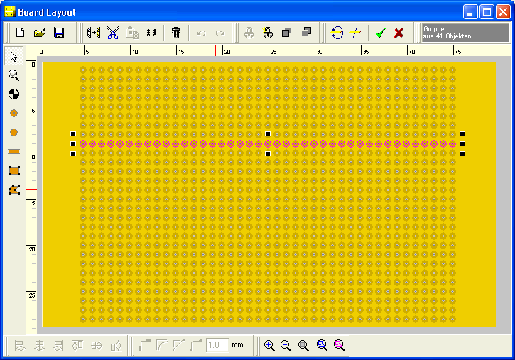

The functions of the board editor are almost the same as the functions of the main program. The following additional functions are available.

Pads with drilling
A dialog requests values for pad diameter and drill diameter. After that you can place pads with drillings anywhere on the board with a single mouse click. The right mouse button terminates this mode.

Pads without drilling
A dialog requests the pad diameter. After that you can place pads anywhere on the board with a single mouse click. The right mouse button terminates this mode.

Tracks
A dialog requests the width for the track. The first click determines the start position for the track. Move the mouse cursor to the end position of the track and click again.The right mouse button terminates this mode.

The rectangle function and the polygon function are the same as in the main program and can be used to draw copper areas as well.

Click this button to ACCEPT the board layout for your board. The layout editor is closed and the software returns to your current project, with your new board layout.

Click this button to REJECT the board layout. The layout editor is closed and the software returns to your current project. The board layout will not be changed.

The board layout for each board of your project is saved automatically with the project file (*.rst). The board layout editor allows you save the board layout, independently and separately from your project file as template file (*.LMB). It is strongly recommended to save these files to the BOARD LAYOUTS directory in the installation path of your software, where also the predefined board layouts can be found.

Once again:

The main application saves and opens only files with the extension (*.RST), which are project files that include all data of a project.

The board layout editor saves and opens only files with the extension (*.LMB), which only include the board layout (dimension, copper and drillings). These files are used as templates, when starting a new project or adding a new board to a project.

5. Examples

Three simple examples have been installed with the software.

LED_Driver.RST a simple LED-driver for use with TTL-output.
Relay_Driver.RST a simple relay-driver for use with TTL-output.
LM317T.RST a simple, adjustable voltage control using the LM317T.

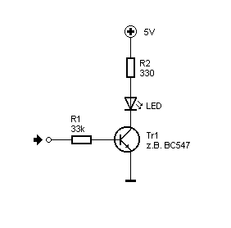
Fig. - LED-driver
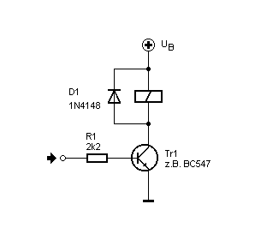
Fig.- Relay driver

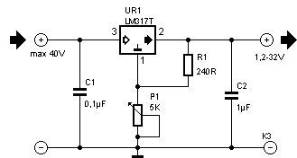

Fig. - Power supply using the LM317T.

